Part 1: The Final Hurdle—Why Do Creators Waste a Fortune on BGM Only to End Up Frustrated?
Let’s set the scene: You are an independent video creator. You’ve just finished editing your latest masterpiece, and there’s only one thing left to do—the "BGM."

At this critical final stage, you dive into a music library searching for the perfect track to build tension for a challenge. But the results? Nothing but generic stock music that’s been used in hundreds of other videos. You scroll through 20 full pages and finally find a track that, while mediocre in quality, at least hits the right tempo.

You drag the file onto your timeline, sync it up, and you’re seconds away from finishing! But then you remember to check the library’s licensing agreement, and the results are a total shock: What? You have to pay ongoing royalties to get clearance?

"I'll just find another library!" you tell yourself. You find a premium site boasting tens of thousands of high-quality tracks. But when you search using the same keywords, the same tracks pop up. Watching the same repetitive material appear across different "exclusive" libraries is enough to make anyone want to break down and cry.

This is the reality: Content across different platforms is highly redundant, making it nearly impossible to find something truly unique. Desperate, you try contacting an external composition team. The result? A quote starting at $500 and a week-long communication cycle. With your deadline looming, you ask for a quick demo to check the direction. Their response? A 50% upfront deposit is required, and they retain the copyright to the demo itself...

Good grief. Isn’t there a solution to these problems? You’re only a few audio clips away from the finish line!
Part 2: Use MakeBestMusic to Solve All Your Commercial Licensing Needs
If you are a video creator struggling with these same issues, it’s time to try MakeBestMusic

Unlike the traditional "library model," MakeBestMusic allows the music to adapt to your content, rather than forcing you to compromise with overused, low-quality stock assets. With MakeBestMusic, you can use specific prompts or reference your favorite musical samples to precisely capture the "vibe" in your head through text-to-song technology.

With this tool, the massive time and financial burdens of expensive, slow-moving external composers are no longer a necessity. Furthermore, the ReCreate feature allows you to fine-tune the rhythm, instrumentation, or style in seconds. This level of efficiency gives you an unparalleled competitive edge when bidding for commercial projects or racing against a deadline.

Perhaps the most reassuring aspect for creators is the total elimination of copyright risk. Based on our tests and observations, MakeBestMusic provides the most comprehensive commercial license of any AI music tool on the market for its paid subscribers. This means every second of music you generate becomes your personal legal asset.

Not only can you say goodbye to cryptic licensing agreements, but you’ll never have to worry about "Copyright Strikes" or infringement emails again. The platform grants you near-infinite rights over your work: you can remix and restructure tracks, use them as background music for social media, commercial ads, or even game scenes, and even act as the rights holder to license the music to third parties or sell it on digital stores. In short, the ownership, usage, and revenue rights to the BGM belong entirely to you. You are the true master of music.
Part 3: Practical Application—How Custom Audio Licensing Adds Value
Now, let’s look at one of the most popular video formats across streaming platforms—Challenge Videos—to see how MakeBestMusic creates unique, high-quality BGM while boosting your views, engagement, and revenue.
We’ll focus on the two most critical moments in this genre: the "Tense Challenge Process" and the "Successful Highlight Moment." Here is how you can use this tool to overcome copyright hurdles and speed up your production.

1. Two Birds, One Stone: Create Music and Earn Royalties
The challenge process is often the most suspenseful part of a video. This is where creators use slow-motion, Hitchcock zooms, or other cinematic techniques to build tension. At this moment, you need music that complements that stress; you don't want your audience to get bored by generic tracks and swipe away, which hurts your completion rate.
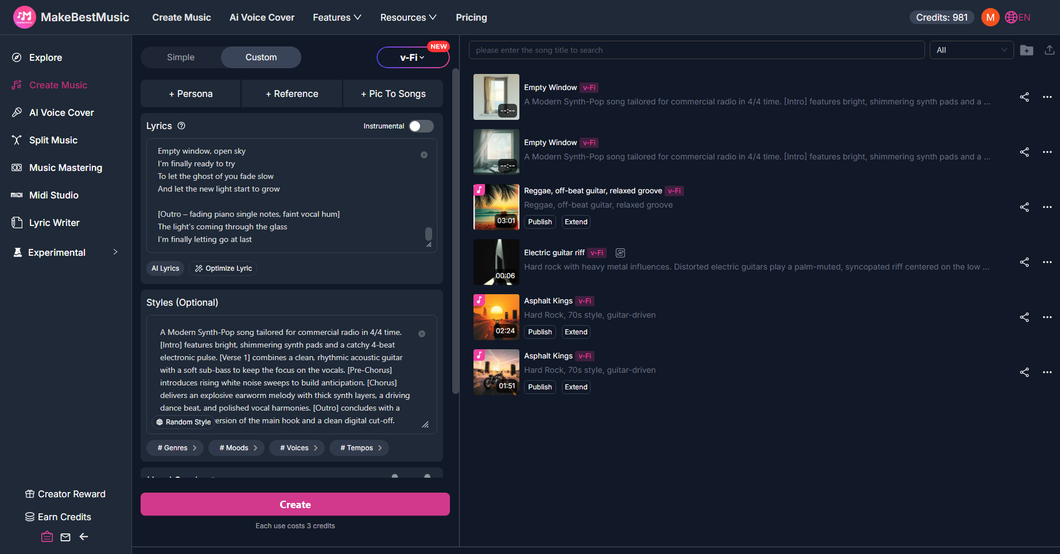
First, enter the MakeBestMusic main interface. Select Create Music on the top left, enter Custom mode, and in the "Style" box, enter your prompts to create your own music.

Once the music is generated, think back to those barren stock libraries. Now, you’ve generated music that not only surpasses those outdated tracks in quality but also fills a gap in the market.

Since MakeBestMusic’s clear commercial terms allow you to use your creations for any business purpose, you can actually upload these high-quality tracks to various music libraries and streaming sites. By filling these market gaps, you aren't just getting better material for yourself—you can also act as the copyright owner to license the tracks to others, earning a tidy sum in royalties along the way.
2. Emotional Resonance: Turn Your Story into Music to Drive Traffic
Then comes the big moment: the protagonist has endured the struggle and finally completed the extraordinary challenge. This is the peak of emotional resonance. At the end of the video, you can use MakeBestMusic to compose a narrative piece tailored to your story. Increasing the emotional impact encourages viewers to leave more comments and "bullet chats," which signals the platform’s algorithm to push your video further.

Furthermore, the commercial license allows you to share your video’s music as standalone tracks on other streaming platforms. This means you can build your brand across multiple platforms (like Spotify or Apple Music) using your audio content, creating a cross-platform funnel that drives traffic back to your main videos and boosts your follower count, loyalty, and streaming revenue.

If you feel that instrumental music isn’t enough, you can even turn your personal reflections and the hardships of the process into lyrics:
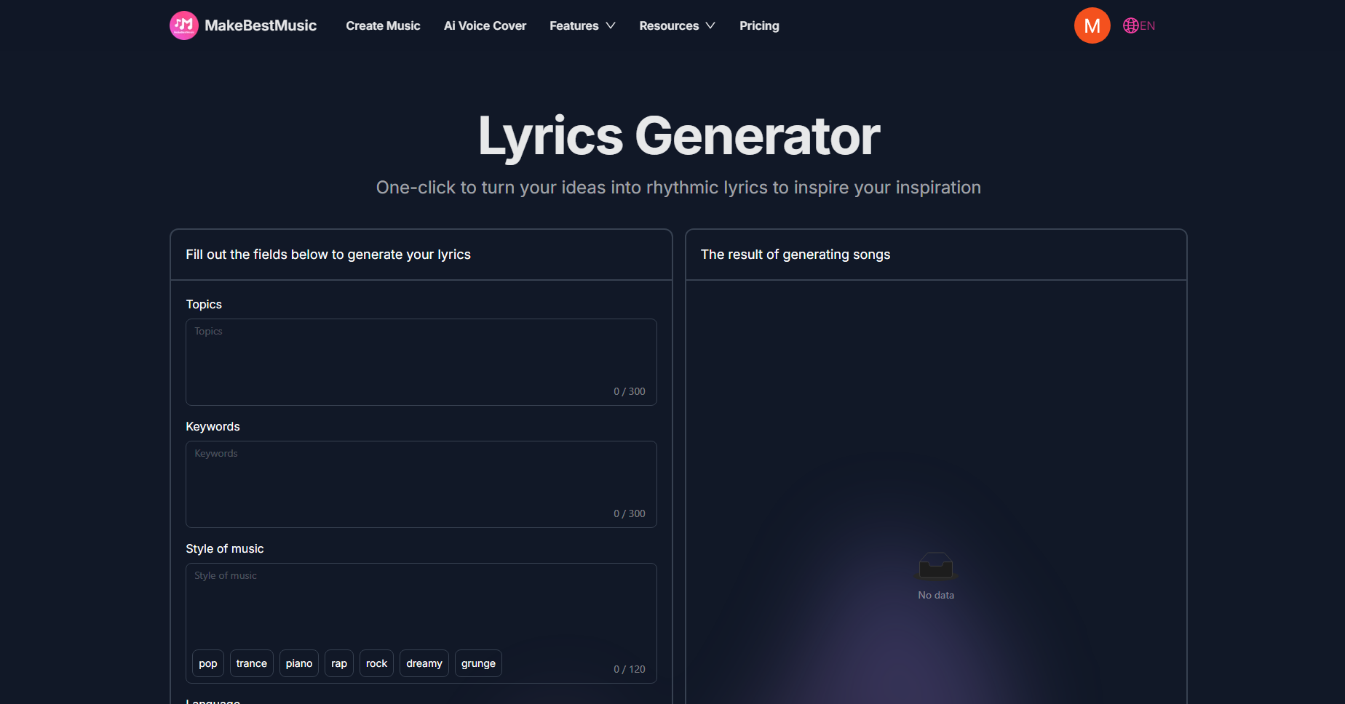
Go to Features at the top of the homepage and open the Lyrics Generator. In "Topics," enter your video outline or story (e.g., "After three months of hellish training, you are finally on the verge of beating a pro player"). Then, set your "Style of Music" and click Generate. With these high-quality lyrics and music, you can present your video content in a musical format to users on other platforms, expanding your traffic pool and diversifying your operations.
FAQ
1. Can music generated by MakeBestMusic be used for any commercial purpose?
Yes. MakeBestMusic creates entirely original works rather than sampling existing copyrighted material. The platform provides a clear royalty-free commercial license for subscribers. Tracks generated under a paid plan can be used in YouTube videos, advertisements, streaming platforms, games, and films without paying ongoing royalties to the platform.
2. Where can I view the licensing agreement for my generated works?
After successfully generating music, go to the Create Music interface and look at your list of tracks. Click the ellipsis (...) on the right side of a track and select Commercial License. There, you can view and download the document to verify your rights and permissions.
3. Can I get a written license for business activities or copyright appeals?
Yes. MakeBestMusic provides a formal Commercial License Agreement available for download as a PDF. This document can be used as legal proof of ownership in business dealings. For example, you can use it to claim ownership of your audio on other platforms and collect royalties. Additionally, it serves as an official statement of rights to resolve copyright "flags" on streaming platforms or as evidence in legal proceedings to protect your creative earnings and rights.

Conclusion
Through this walkthrough of MakeBestMusic, it’s clear that we’re not just talking about how to quickly find material for your videos. We’re talking about a fundamental shift in value: your BGM is no longer just a background element; it is an extension of your content that brings immense commercial value and data growth.
Every second of melody you generate becomes a legally protected intellectual property asset. You can finally move past confusing royalty terms and the helplessness of receiving "Copyright Claims." You now have complete commercial control over your music, allowing you to create more freely and efficiently than ever before. With MakeBestMusic, you have the legal foundation to monetize across platforms and scale your business. Open MakeBestMusic today—let every melody become your irreplaceable, exclusive asset.

